University of Central Missouri

Department of Computer Science & Cybersecurity

CS5720 Neural network and Deep learning

Fall 2026

Home Assignment 3.

Student name: Ruyi Gai

Submission Requirements:
- Total Points: 100
- Once finished your assignment push your source code to your repo (GitHub) and explain the work through the ReadMe file properly. Make sure you add your student info in the ReadMe file.
- Submit your GitHub link on the Bright Space.
- Comment your code appropriately IMPORTANT.
- Any submission after provided deadline is considered as a late submission.

Part I — Short-Answer Questions
Question 1 — Convolution, Padding, and Stride
A convolutional layer receives an input image of size 32 × 32 × 3. It uses 16 filters of size 5 × 5, stride S = 1, and padding P = 0.
a. What are N, F, S, and P?
b. Calculate the height and width of the output feature map using:
$$N_{out}=\frac{N-F+2P}{S}+1$$
c. What is the complete output volume, including the number of channels?
d. If padding is changed so that the spatial dimensions remain 32 × 32, what padding value should be used?
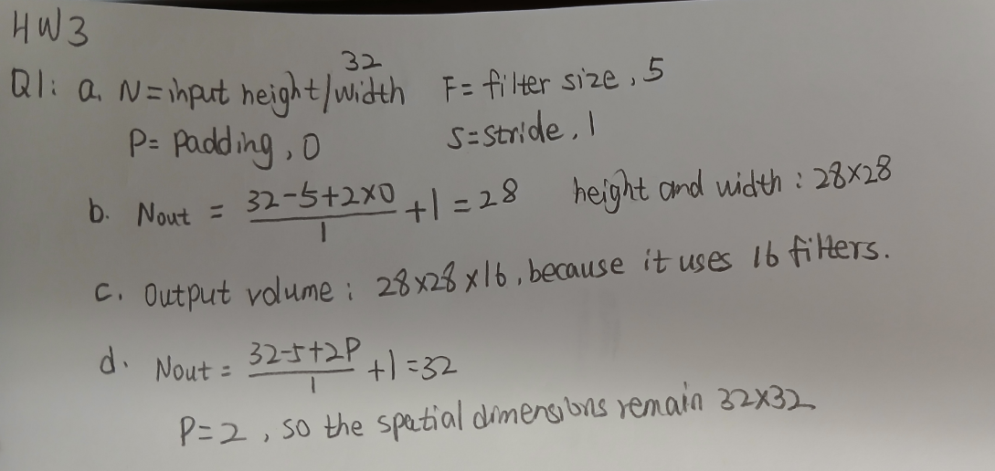
Question 2 — CNN Architectures
Consider AlexNet, VGGNet, GoogLeNet, and ResNet.
- What was one important contribution of AlexNet?
AlexNet showed that deep networks can learn complex representations, facilitated by GPUs and large datasets such as ImageNet.
- Why does VGGNet use multiple small 3 × 3 convolutional filters instead of very large filters?
Three 3 × 3 convolutional layers have the same effective receptive field as one 7 × 7 layer, while providing more nonlinearities and fewer parameters.
- What is the main idea of the Inception module in GoogLeNet?
The Inception module uses multiple parallel operations, such as different convolution sizes and pooling, and concatenates their outputs.
- What problem does residual learning in ResNet help address?
Residual learning helps address the degradation problem and optimization difficulties that occur when training very deep neural networks. Skip connections also help gradients flow more easily through the network.
Question 3 — Representation Learning and Transfer Learning
- What is representation learning?
Representation learning is learning useful feature representations from data to simplify downstream tasks.
- Explain why lower CNN layers often learn different features than higher CNN layers.
Lower CNN layers learn simple features such as edges and textures, while higher layers learn more complex features based on the features learned by lower layers, such as objects and faces.
- What is transfer learning/fine-tuning?
Transfer learning uses a pretrained network as a starting point for a different dataset and/or task. Fine-tuning adapts the pretrained network to the new dataset or task.
- Suppose you have a small image dataset. Why might you start with a pretrained CNN instead of training a deep CNN completely from scratch?
A pretrained CNN has already learned useful feature representations, so it provides a good starting point for a new dataset or task instead of training the network completely from scratch.
- What is the difference between freezing a layer and fine-tuning a layer?
Freezing a layer keeps its pretrained parameters fixed, while fine-tuning a layer allows its parameters to be updated on the new dataset.

Part II — Programming Questions
Question 1 — Implement Convolution from Scratch
Write a Python program that performs 2-D convolution/filtering without using a built-in convolution function.
Use the following input:
Input:
1 1 1 0 0
0 1 1 1 0
0 0 1 1 1
0 0 1 1 0
0 1 1 0 0

Filter:
1 0 1
0 1 0
1 0 1
Use stride = 1 and padding = 0.
Your program must:
a. Store the input and filter using NumPy arrays.
b. Slide the filter over the input matrix.
c. Compute the dot product at every valid location.
d. Print the complete output feature map.
e. Print the output shape.
f. Briefly explain how changing the stride from 1 to 2 would affect the output.

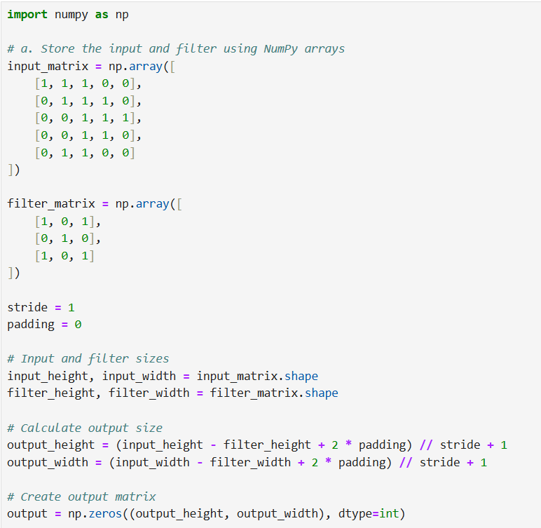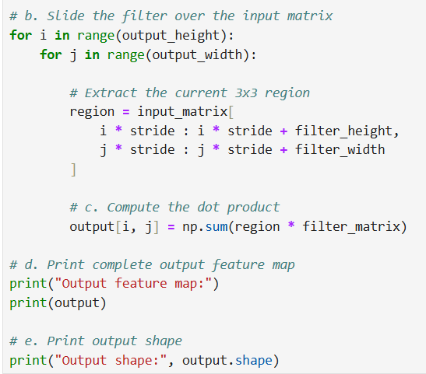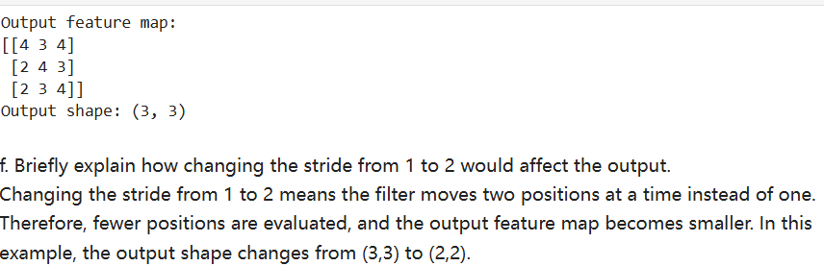

Question 2 — Transfer Learning: Freeze vs. Fine-Tune
Use a pretrained model such as ResNet18, ResNet50, VGG16, or another standard pretrained CNN.
Use an image-classification dataset with at least two classes.
Experiment A — Feature Extraction
- Load the pretrained network.
- Freeze the convolutional/base layers.
- Replace the final classification layer.
- Train only the new classifier.
Experiment B — Fine-Tuning
- Start with the pretrained network.
- Unfreeze at least the last convolutional block.
- Train the unfrozen layers and classifier.
For both experiments:
a. Report the number of trainable parameters.
b. Train for the same number of epochs.
c. Record training time.
d. Report test or validation accuracy.
e. Plot training loss.
f. Compare the two approaches in a table:
Method | Trainable Parameters | Training Time | Accuracy
Frozen Feature Extractor | 1026 | 52.77 | 80.39%
Fine-Tuned Network | 8394754 | 79.32 | 92.81%
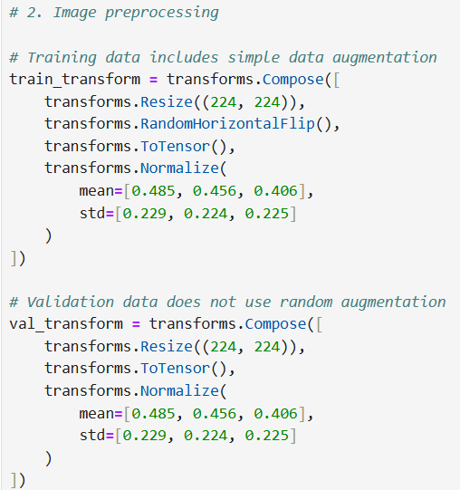
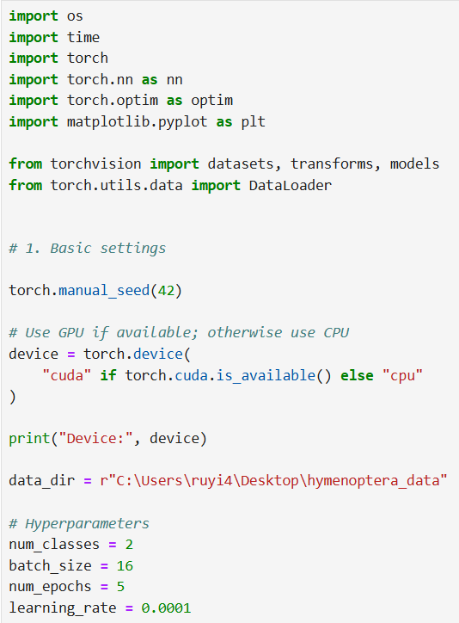
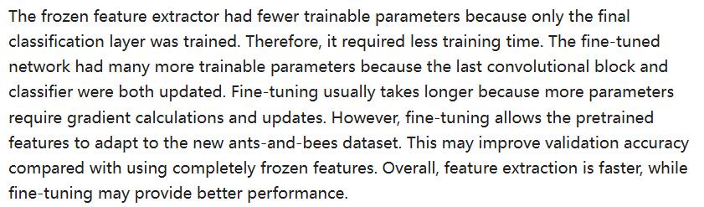
g. In 5–8 sentences, discuss the results. Explain why freezing layers and fine-tuning layers may produce different training times and performance.

